SYSTEM CALLS

PROGRAM 1

#include <sys/types.h>
#include <stdio.h>
#include <unistd.h>

int main() {
int pid;
pid = fork();

if(pid<0) {
fprintf(stderr, "Fork failed");
}
else if(pid==0) {
printf("Child id : %d\n", getpid());
printf("Parent id : %d\n", getppid());
}
else {
wait(NULL);
printf("Parent present\n");
printf("Parent id : %d\n", getpid());
}
}

OUTPUT

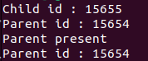

PROGRAM 2

execvp_p2.c

#include <stdio.h>
#include <sys/types.h>
#include <sys/wait.h>
#include <unistd.h>
#include <stdlib.h>

int main() {
char *args[] = {"./sample", NULL};
execvp(args[0], args);
printf("Empty");
}

sample.c

#include <stdio.h>

int main() {
printf("File is called usng execvp\n");
}

OUTPUT

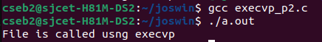

PROGRAM 3

echo Enter the first number :
read num1
echo Enter the second number :
read num2

if(($num1>$num2))
then
echo Biggest is $num1
else
echo Biggest is $num2
fi

OUTPUT

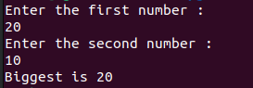

PROGRAM 4

echo Enter the limit :
read n

echo The first $n natural number is :
for((i=1; i<=n; i++))
do
echo $i
done

OUTPUT

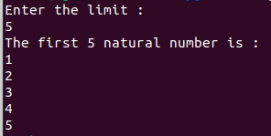

PROGRAM 5

echo Enter the number :
read n
fact=1

for((i=1; i<=n; i++))
do
fact=$((fact*i))
done

echo The factorial is $fact

OUTPUT

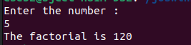

PROGRAM 6

echo Enter the limit
read n

a=0
b=1

echo The first $n fibonacci numbers :
for((i=1; i<=n; i++))
do
c=$((a+b))
echo $a
a=$b
b=$c
done

OUTPUT

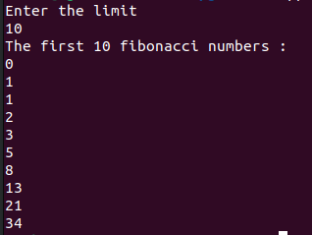

PROGRAM 7

echo "Enter the first number : "
read n1
echo "Enter the second number : "
read n2
echo "1) ADDITION
2) SUBTRACTION
3) MULTIPLICATION
4) DIVISION
Choose the operation : "
read op

case $op in
1) echo THE SUM IS $(($n1+$n2));;
2) echo THE DIFFERENCE IS $(($n1-$n2));;
3) echo THE PRODUCT IS $(($n1*$n2));;
4) echo THE QUOTIENT IS $(($n1/$n2));;
*) echo Wrong choice;;
esac

OUTPUT

